<https://kubernetes.io/docs/concepts/overview/components/>

The kubelet takes a set of PodSpecs

Kube control plane (master node)

* Kube api server(API that exposes Kubernetes API, it is frontend Kubernetes control plane or master node and it maintains the traffic between Master and worker nodes)
* Kube-scheduler (Watches for newly created pods with no assigned node and selects a node for them to run)

Factors taken into account for scheduling decisions includes individual and collective resource requirements, hardware/software/policy constraints, affinity and anti-affinity specifications, data locality, inter-workload interference, and deadlines.

* Kube controller manager:

Control Plane component that runs controller processes.

Logically, each controller is a separate process, but to reduce complexity, they are all compiled into a single binary and run in a single process.

These controllers include:

Node controller: Responsible for noticing and responding when nodes goes down.

Replication controller: Responsible for maintaining the correct number of pods for every replication controller object in the system.

Endpoints controller: Populates the Endpoints object (that is, joins Services & Pods).

Service Account & Token controllers: Create default accounts and API access tokens for new namespaces

* Etcd (Consistent and highly-available key value store used as Kubernetes’ backing store for all cluster data)

And it stores all the Kubernetes object data such as selectors, nodes, pods, lables and ports all such information.

Node (worder nodes)

* Kubelet:

An agent that runs on each [node](https://kubernetes.io/docs/concepts/architecture/nodes/) in the cluster. It makes sure that [containers](https://kubernetes.io/docs/concepts/overview/what-is-kubernetes/#why-containers) are running in a [Pod](https://kubernetes.io/docs/concepts/workloads/pods/pod-overview/).

The kubelet takes a set of PodSpecs that are provided through various mechanisms and ensures that the containers described in those PodSpecs are running and healthy. The kubelet doesn’t manage containers which were not created by Kubernetes.

* Kube proxy:

kube-proxy is a network proxy that runs on each node in your cluster, implementing part of the Kubernetes Service concept.

kube-proxy maintains network rules on nodes. These network rules allow network communication to your Pods from network sessions inside or outside of your cluster.

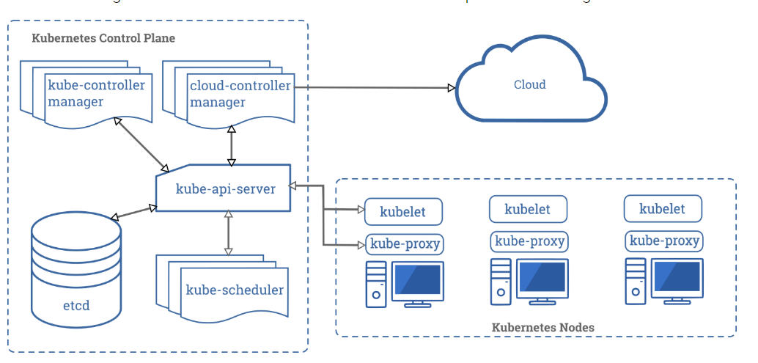

Kubernetes network model

<https://kubernetes.io/docs/concepts/cluster-administration/networking/>

**Metadata** summarizes basic information about data, which can make finding and working with particular instances of data easier.

Writing yaml files: <https://www.mirantis.com/blog/introduction-to-yaml-creating-a-kubernetes-deployment/>

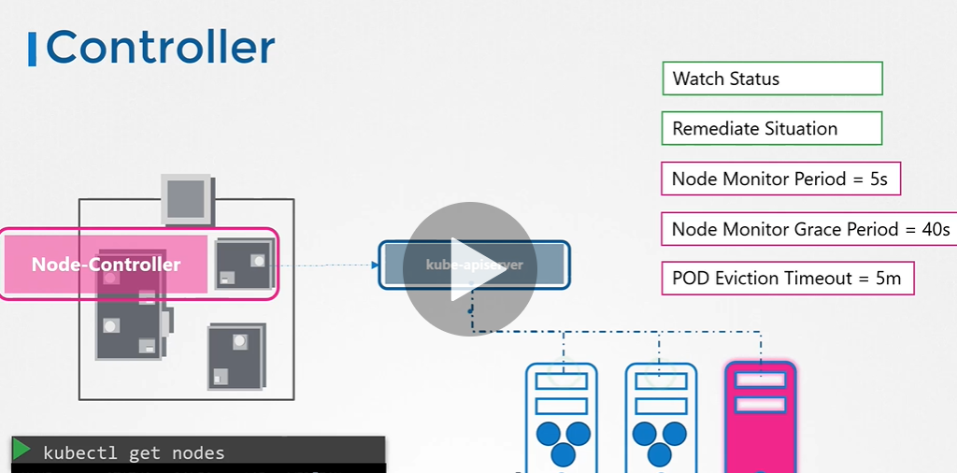

Yaml file ref: <https://kubernetes.io/docs/concepts/workloads/controllers/replicaset/>

It tells which api we can use for object: <https://kubernetes.io/docs/reference/generated/kubernetes-api/v1.18/>

Kubernetes imperative commands llist: <https://kubernetes.io/docs/tasks/manage-kubernetes-objects/imperative-command/>

Namespaces: kubectl get pods –namespace=dev

Kubectl config set-context $(kubectl config current-contect) –namespace=dev

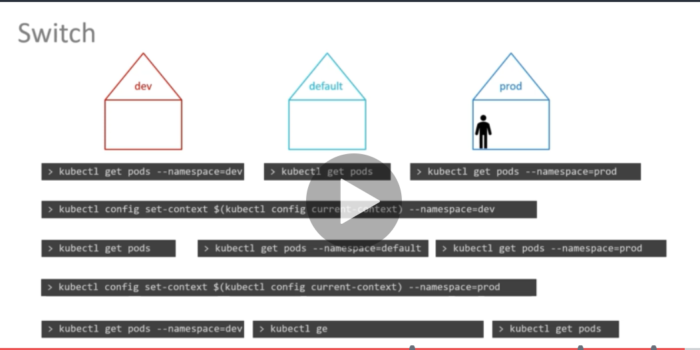

Schedulers:

Kubectl get pods –selector type=frontend

Kubectl get all –selecter env=prod (it will list all the objects of the prod environment)

Taints and tolerants: Taints set on nodes, tolerants set on pods

Kubectl taint nodes node-name key=value:taint-effect

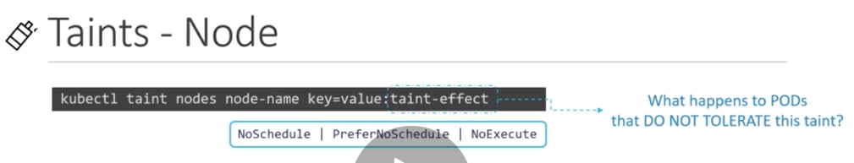

NoSchedule: Pods will be scheduled with tolerations, existing pods won’t be evicted

PreferNoScheule: system will try to avoid, but that is not gurantee

NoExecute: New pods will nbe scheduled, existing pods will be evicted

Ex: kubectl taint nodes node1 app=blue:NoSchdule

Untaint : kubectl taint nodes --all app=dev:NoSchedule-

kubectl taint nodes --all node-role.kubernetes.io/master-

Tip: <https://www.udemy.com/course/certified-kubernetes-administrator-with-practice-tests/learn/lecture/14937592#notes>

kubectl -n kube-system get ds | grep weave-net

kubectl create deployment elasticsearch --image=imagename –dry-run -o yaml > elastic.yaml (to create sample yaml file)

pending with static pods

Taints and Nodeaffinity: The main difference b/w both taint & tolerations and NodeAffinity is

* Taints & tolerations: we usually declare taints values in yaml, scheduler initially looks for tainted once if it is occupied , then the pod will be deployed in some other free node (if all those are tainted, the pod wont be deployed at all)
* NodeAffinity: Using node affinity we can specify key & values in yaml file of the POD. Then the scheduler looks for the exact node and deploys the pod in same node & it wont deploy in any other node. But at the same other pods where keys & values are not defined in yaml file could also be deployed.
* In order to overcome the drawbacks in both, we can use combination of both taints & nodeaffinity to deploy in the specified node

nodeSelector & nodeAffinity: The main difference b/w both the things is

* nodesSelector: we could only mention one key value (suppose if want to specify multiple key matched values this won’t be useful)
* nodeAffinity: we could use multiple keys and values

to know the static pod path , we can check the service definition file of the kubelet of master node

cat /etc/system/system/kubelet.service.d/**.conf

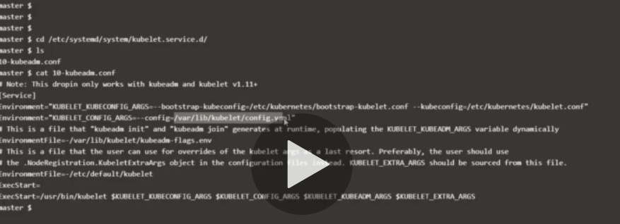

We can search static pod path in the /var/libe/kubelet/config.yaml file

Monitoring & Logging  
to get cpu and memory stats :

Kubectl top node

Multi containers;

In a multi-container pod, each container is expected to run a process that stays alive as long as the POD's lifecycle. For example in the multi-container pod that we talked about earlier that has a web application and logging agent, both the containers are expected to stay alive at all times. The process running in the log agent container is expected to stay alive as long as the web application is running. If any of them fails, the POD restarts.

But at times you may want to run a process that runs to completion in a container. For example a process that pulls a code or binary from a repository that will be used by the main web application. That is a task that will be run only  one time when the pod is first created. Or a process that waits  for an external service or database to be up before the actual application starts. That's where **initContainers**comes in.

An **initContainer**is configured in a pod like all other containers, except that it is specified inside a initContainers section,  like this:

1. apiVersion: v1
2. kind: Pod
3. metadata:
4. name: myapp-pod
5. labels:
6. app: myapp
7. spec:
8. containers:
9. - name: myapp-container
10. image: busybox:1.28
11. command: ['sh', '-c', 'echo The app is running! && sleep 3600']
12. initContainers:
13. - name: init-myservice
14. image: busybox
15. command: ['sh', '-c', 'git clone <some-repository-that-will-be-used-by-application> ; done;']

When a POD is first created the initContainer is run, and the process in the initContainer must run to a completion before the real container hosting the application starts.

You can configure multiple such initContainers as well, like how we did for multi-pod containers. In that case each init container is run **one at a time in sequential order**.

If any of the initContainers fail to complete, Kubernetes restarts the Pod repeatedly until the Init Container succeeds.

1. apiVersion: v1s
2. kind: Pod
3. metadata:
4. name: myapp-pod
5. labels:
6. app: myapp
7. spec:
8. containers:
9. - name: myapp-container
10. image: busybox:1.28
11. command: ['sh', '-c', 'echo The app is running! && sleep 3600']
12. initContainers:
13. - name: init-myservice
14. image: busybox:1.28
15. command: ['sh', '-c', 'until nslookup myservice; do echo waiting for myservice; sleep 2; done;']
16. - name: init-mydb
17. image: busybox:1.28
18. command: ['sh', '-c', 'until nslookup mydb; do echo waiting for mydb; sleep 2; done;']

Read more about initContainers here. And try out the upcoming practice test.

Self Healing Applications

Kubernetes supports self-healing applications through ReplicaSets and Replication Controllers. The replication controller helps in ensuring that a POD is re-created automatically when the application within the POD crashes. It helps in ensuring enough replicas of the application are running at all times.

Kubernetes provides additional support to check the health of applications running within PODs and take necessary actions through Liveness and Readiness Probes. However these are not required for the CKA exam and as such they are not covered here. These are topics for the Certified Kubernetes Application Developers (CKAD) exam and are covered in the CKAD course.

Kubernetes commands:

Kubectl get all -all-namespaces -o yaml > all-deploy-services.yaml (to get all namespaces)

The below command is for testing whether all the given values are passed or not.

*************ETCDTL_API=3 etcdtl member list –cacert=/etc/Kubernetes/pki/etcd/ca.crt –cert=/etc/ckubernetes/pki/etcd/server.crt –key=/etc/Kubernetes/pki/etcd/server/key – endpoints=127.0.01:2379 ****

The below command is to backup the etcd server

*************ETCDTL_API=3 etcdtl snapshot save –cacert=/etc/Kubernetes/pki/etcd/ca.crt –cert=/et/ckubernetes/pki/etcd/server.crt –key=/etc/Kubernetes/pki/etcd/server/key –endpoints=127.0.01:2379 /tm/snapshot.db****

The below command is to restore the backup

*************ETCDTL_API=3 etcdtl snapshot restore –cacert=/etc/Kubernetes/pki/etcd/ca.crt –cert=/et/ckubernetes/pki/etcd/server.crt –key=/etc/Kubernetes/pki/etcd/server/key –endpoints=127.0.01:2379 –data-dir=”/var/lib/etcd-backup” initial-cluster=”master=https://127.0.01:2380” –initial-cluster-token=”etcd-cluster-1” /tmp/snapshot.db****

After restoring the DB, we have enter, initial-cluster-token, data-dir, mount path in the etcd yaml under manifests location. Need to recreate the etcd pod

Reference link: <https://kubernetes.io/docs/tasks/administer-cluster/configure-upgrade-etcd/#backing-up-an-etcd-cluster>

Working with ETCDCTL

etcdctl is a command line client for **[etcd](https://github.com/coreos/etcd)**.

In all our Kubernetes Hands-on labs, the ETCD key-value database is deployed as a static pod on the master. The version used is v3.

To make use of etcdctl for tasks such as back up and restore, make sure that you set the ETCDCTL_API to 3.

You can do this by exporting the variable ETCDCTL_API prior to using the etcdctl client. This can be done as follows:

export ETCDCTL_API=3

On the **Master Node**:

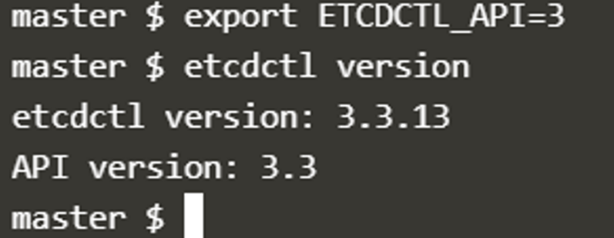

To see all the options for a specific sub-command, make use of the**-h or --help** flag.

For example, if you want to take a snapshot of etcd, use:

etcdctl snapshot save -h and keep a note of the mandatory global options.

Since our ETCD database is TLS-Enabled, the following options are mandatory:

--cacert                                                verify certificates of TLS-enabled secure servers using this CA bundle

--cert                                                    identify secure client using this TLS certificate file

--endpoints=[127.0.0.1:2379]          This is the default as ETCD is running on master node and exposed on localhost 2379.

--key                                                      identify secure client using this TLS key file

Similarly use the help option for **snapshot restore**to see all available options for restoring the backup.

etcdctl snapshot restore -h

For a detailed explanation on how to make use of the etcdctl command line tool and work with the -h flags, check out the solution video for the Backup and Restore Lab.

Security:

Article on Setting up Basic Authentication

Setup basic authentication on kubernetes

Note: This is not recommended in a production environment. This is only for learning purposes.

Follow the below instructions to configure basic authentication in a kubeadm setup.

Create a file with user details locally at /tmp/users/user-details.csv

1. # User File Contents
2. password123,user1,u0001
3. password123,user2,u0002
4. password123,user3,u0003
5. password123,user4,u0004
6. password123,user5,u0005

Edit the kube-apiserver static pod configured by kubeadm to pass in the user details. The file is located at /etc/kubernetes/manifests/kube-apiserver.yaml

1. apiVersion: v1
2. kind: Pod
3. metadata:
4. name: kube-apiserver
5. namespace: kube-system
6. spec:
7. containers:
8. - command:
9. - kube-apiserver
10. <content-hidden>
11. image: k8s.gcr.io/kube-apiserver-amd64:v1.11.3
12. name: kube-apiserver
13. volumeMounts:
14. - mountPath: /tmp/users
15. name: usr-details
16. readOnly: true
17. volumes:
18. - hostPath:
19. path: /tmp/users
20. type: DirectoryOrCreate
21. name: usr-details

Modify the kube-apiserver startup options to include the basic-auth file

1. apiVersion: v1
2. kind: Pod
3. metadata:
4. creationTimestamp: null
5. name: kube-apiserver
6. namespace: kube-system
7. spec:
8. containers:
9. - command:
10. - kube-apiserver
11. - --authorization-mode=Node,RBAC
12. <content-hidden>
13. - --basic-auth-file=/tmp/users/user-details.csv

Create the necessary roles and role bindings for these users:

1. ---
2. kind: Role
3. apiVersion: rbac.authorization.k8s.io/v1
4. metadata:
5. namespace: default
6. name: pod-reader
7. rules:
8. - apiGroups: [""] # "" indicates the core API group
9. resources: ["pods"]
10. verbs: ["get", "watch", "list"]
12. ---
13. # This role binding allows "jane" to read pods in the "default" namespace.
14. kind: RoleBinding
15. apiVersion: rbac.authorization.k8s.io/v1
16. metadata:
17. name: read-pods
18. namespace: default
19. subjects:
20. - kind: User
21. name: user1 # Name is case sensitive
22. apiGroup: rbac.authorization.k8s.io
23. roleRef:
24. kind: Role #this must be Role or ClusterRole
25. name: pod-reader # this must match the name of the Role or ClusterRole you wish to bind to
26. apiGroup: rbac.authorization.k8s.io

Once created, you may authenticate into the kube-api server using the users credentials

curl -v -k https://localhost:6443/api/v1/pods -u "user1:password123"

**cmd: watch kubectl get pods (we can observe the status of the pods)**

Replica Set and Replication Controller do almost the same thing. Both of them ensure that a specified number of pod replicas are running at any given time. The difference comes with the usage of selectors to replicate pods. Replica Set use Set-Based selectors while replication controllers use Equity-Based selectors. And using Replicationcontroller we can deploy a set of only a pod with one container, but where as with the repliaset we can deploy a pod with many containers.

Services: <https://www.tutorialspoint.com/kubernetes/kubernetes_service.ht>

**Create an NGINX Pod**

kubectl run --generator=run-pod/v1 nginx --image=nginx

**Generate POD Manifest YAML file (-o yaml). Don't create it(--dry-run)**

kubectl run --generator=run-pod/v1 nginx --image=nginx --dry-run -o yaml

**Create a deployment**

kubectl create deployment --image=nginx nginx

**Generate Deployment YAML file (-o yaml). Don't create it(--dry-run)**

kubectl create deployment --image=nginx nginx --dry-run -o yaml

**Generate Deployment YAML file (-o yaml). Don't create it(--dry-run) with 4 Replicas (--replicas=4)**

kubectl create deployment --image=nginx nginx --dry-run -o yaml > nginx-deployment.yaml

InitContainers

In a multi-container pod, each container is expected to run a process that stays alive as long as the POD's lifecycle. For example in the multi-container pod that we talked about earlier that has a web application and logging agent, both the containers are expected to stay alive at all times. The process running in the log agent container is expected to stay alive as long as the web application is running. If any of them fails, the POD restarts.

But at times you may want to run a process that runs to completion in a container. For example a process that pulls a code or binary from a repository that will be used by the main web application. That is a task that will be run only  one time when the pod is first created. Or a process that waits  for an external service or database to be up before the actual application starts. That's where **initContainers**comes in.

An **initContainer**is configured in a pod like all other containers, except that it is specified inside a initContainers section,  like this:

1. apiVersion: v1
2. kind: Pod
3. metadata:
4. name: myapp-pod
5. labels:
6. app: myapp
7. spec:
8. containers:
9. - name: myapp-container
10. image: busybox:1.28
11. command: ['sh', '-c', 'echo The app is running! && sleep 3600']
12. initContainers:
13. - name: init-myservice
14. image: busybox
15. command: ['sh', '-c', 'git clone <some-repository-that-will-be-used-by-application> ; done;']

When a POD is first created the initContainer is run, and the process in the initContainer must run to a completion before the real container hosting the application starts.

You can configure multiple such initContainers as well, like how we did for multi-pod containers. In that case each init container is run **one at a time in sequential order**.

If any of the initContainers fail to complete, Kubernetes restarts the Pod repeatedly until the Init Container succeeds.

1. apiVersion: v1
2. kind: Pod
3. metadata:
4. name: myapp-pod
5. labels:
6. app: myapp
7. spec:
8. containers:
9. - name: myapp-container
10. image: busybox:1.28
11. command: ['sh', '-c', 'echo The app is running! && sleep 3600']
12. initContainers:
13. - name: init-myservice
14. image: busybox:1.28
15. command: ['sh', '-c', 'until nslookup myservice; do echo waiting for myservice; sleep 2; done;']
16. - name: init-mydb
17. image: busybox:1.28
18. command: ['sh', '-c', 'until nslookup mydb; do echo waiting for mydb; sleep 2; done;']

Read more about initContainers here. And try out the upcoming practice test.

<https://kubernetes.io/docs/concepts/workloads/pods/init-containers/>

Networking:

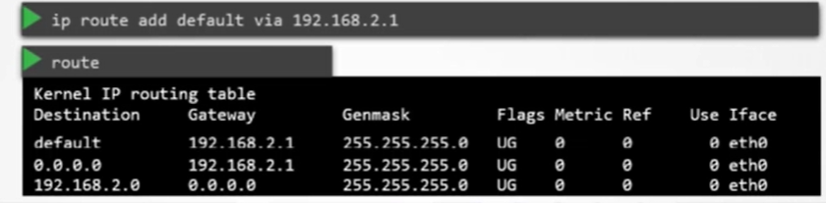

0.0.0.0/default indicates under ‘Desitnation’, it can reach any ip addres globally.

0.0.0.0 indicates under Gateway, no gateway switch required, directly it cant communicate the devise in its ip range. Usually aws configured like this to talk to any ips in the range.

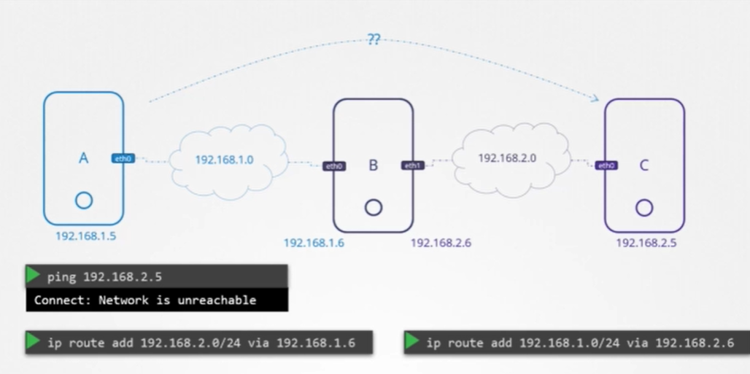

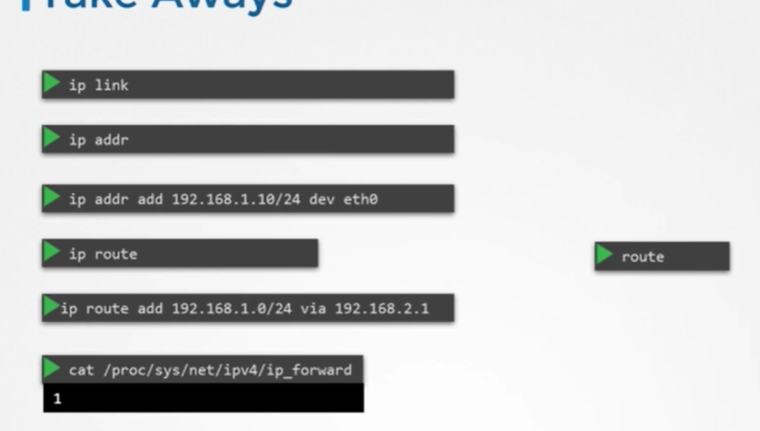

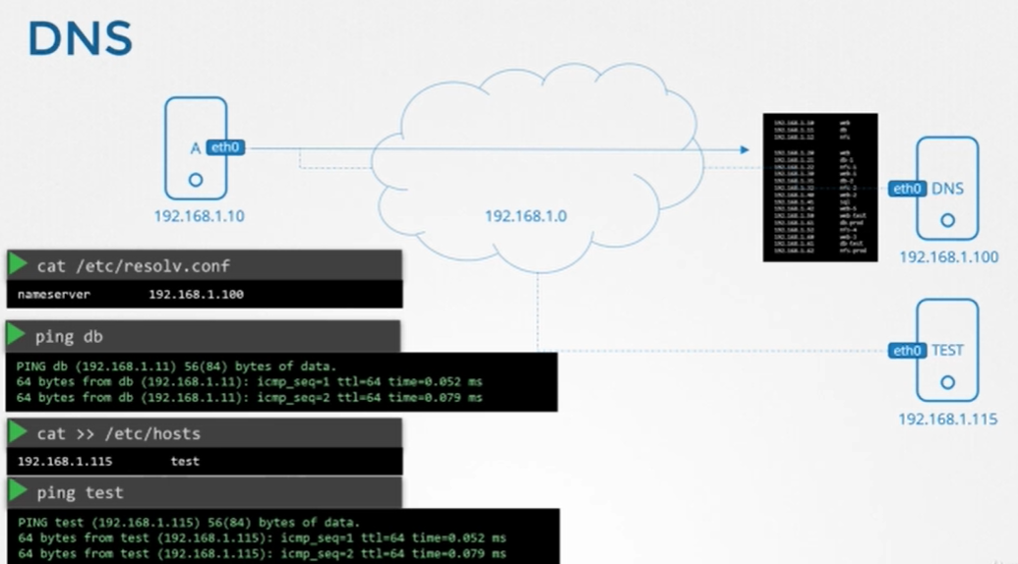

For suppose if we have many servers, and we wish to hit the severs with the name, then we would have to add them in /etc/hosts file. The same thing must be repeated for the hosts in the network range. In future if any modification/new thing added, again we must edit all the /etc/hosts files. Inorder to overcome this thing, we centally manage a DNS server, where we configure all the hostsnames/domainnames with the ip address.

And in the hosts we must add the DNS entry in /etc/resolve.conf , so that we will be able to ping all the ip address.

What if we have set up name for 192.168.50.10 as DB in /etc/hosts file, and DB_Postgre in DNS server. When we hit ping DB, initlly it looks for local config file /etc/hosts and DNS server. This order can be modified by editing entry in /etc/nsswitch.conf

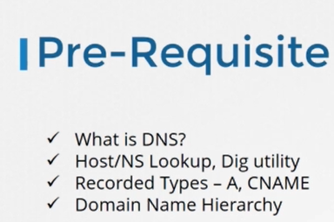

Using the service we can communica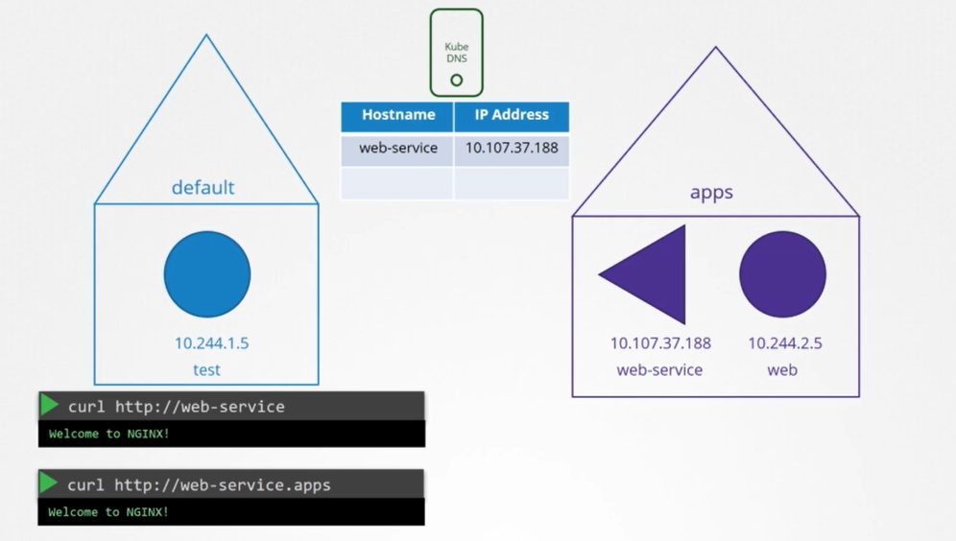

Here apps is the namespace

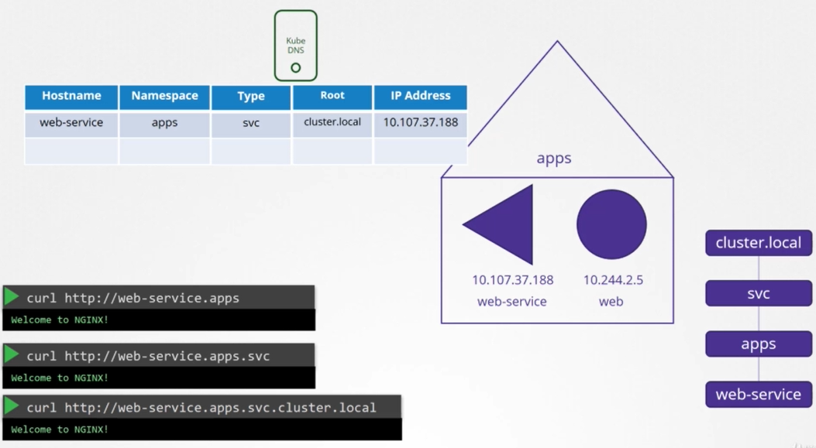

Core DNS in Kubernetes;

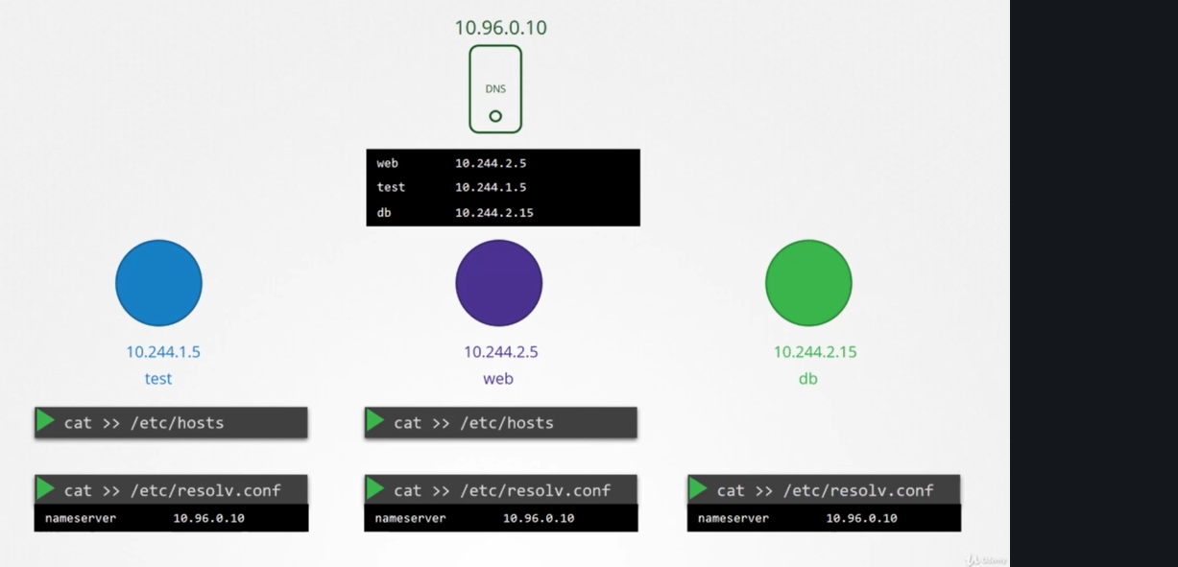

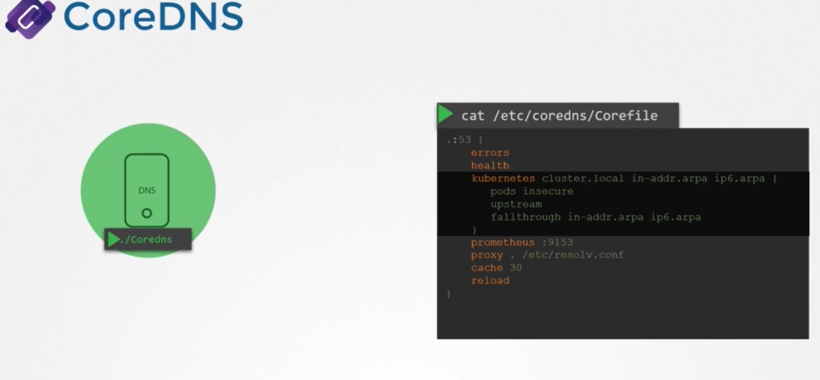

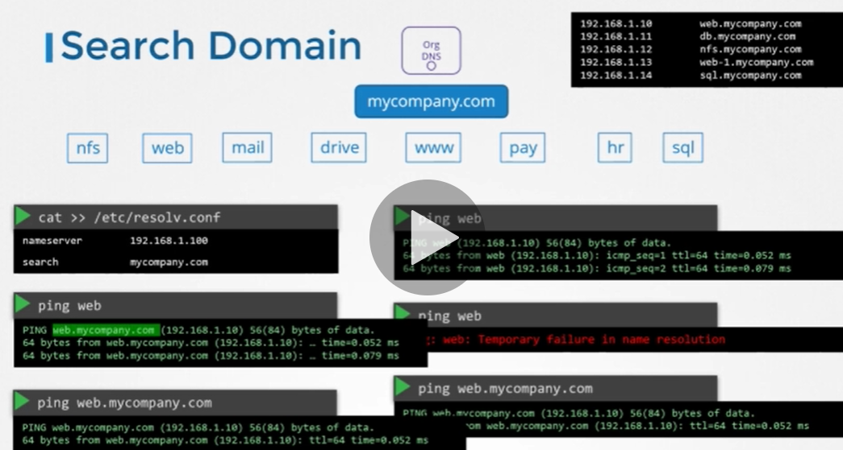

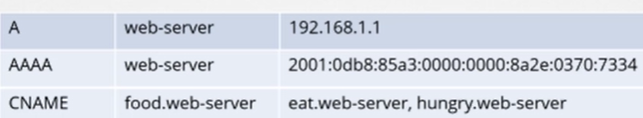

Nsloolup is utility which gives detils about the entry only in DNS server, it wont work for /etc/hosts

Dig is same also a utility

<https://www.udemy.com/course/certified-kubernetes-administrator-with-practice-tests/learn/lecture/14410330#announcements/3613795/> if useful for core-dns

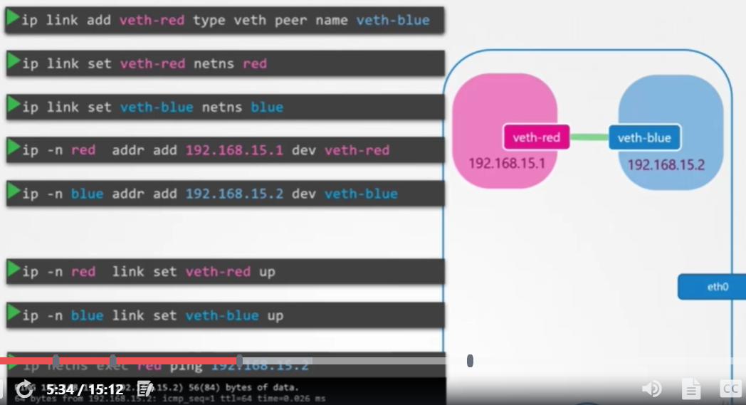

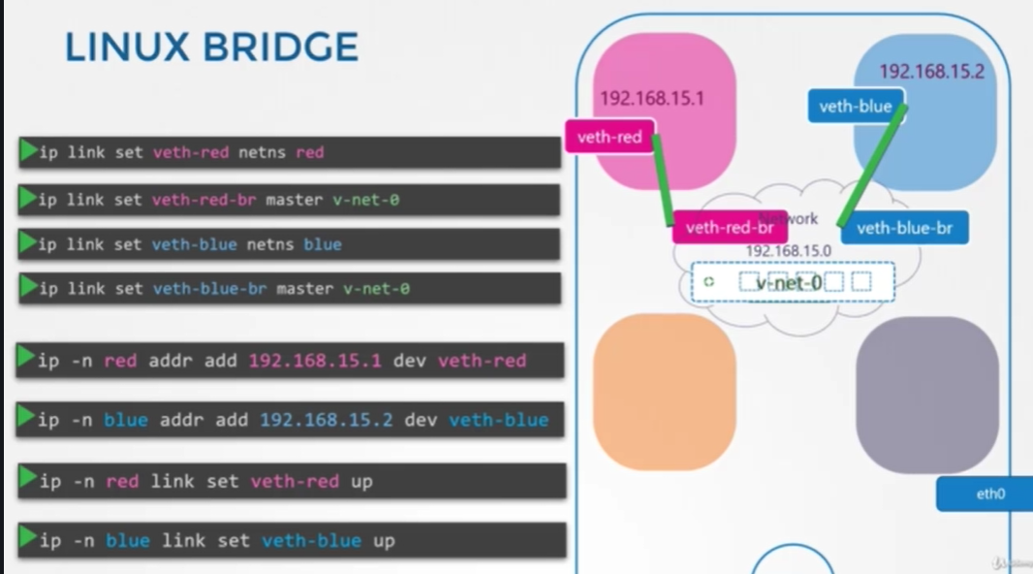

Nat, addting the enties,

Ip netns -🡪 to list the namespaces

When we run a container , we see namespaces under ‘ip netns’ and docker itself a creates connection.

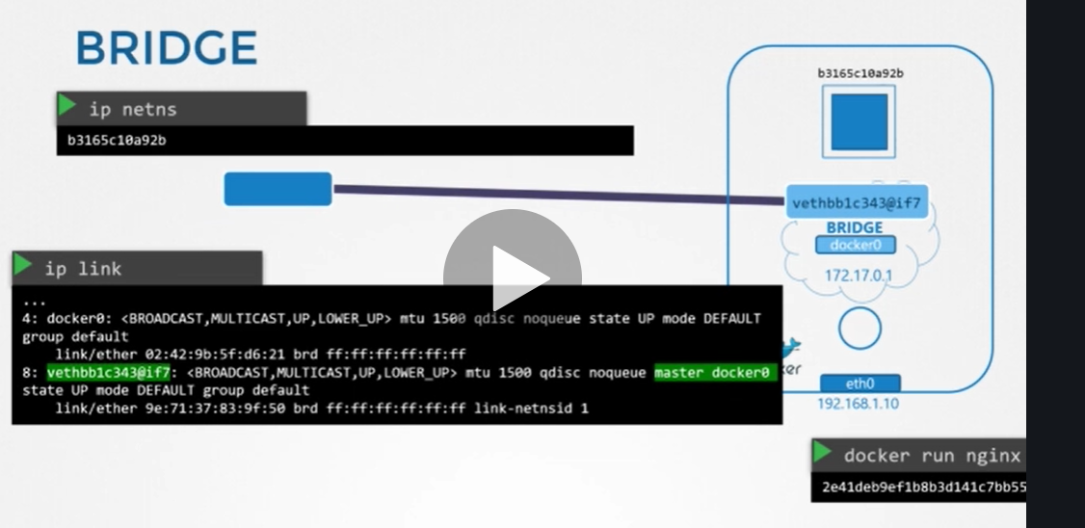

Default network type is ‘bridge’

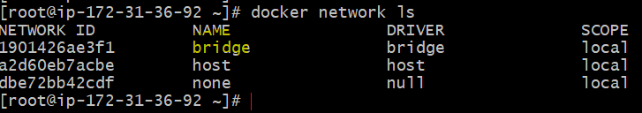

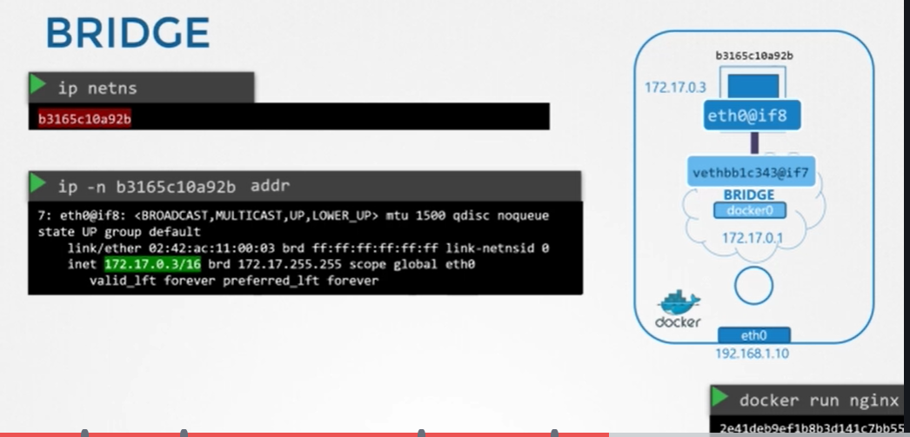

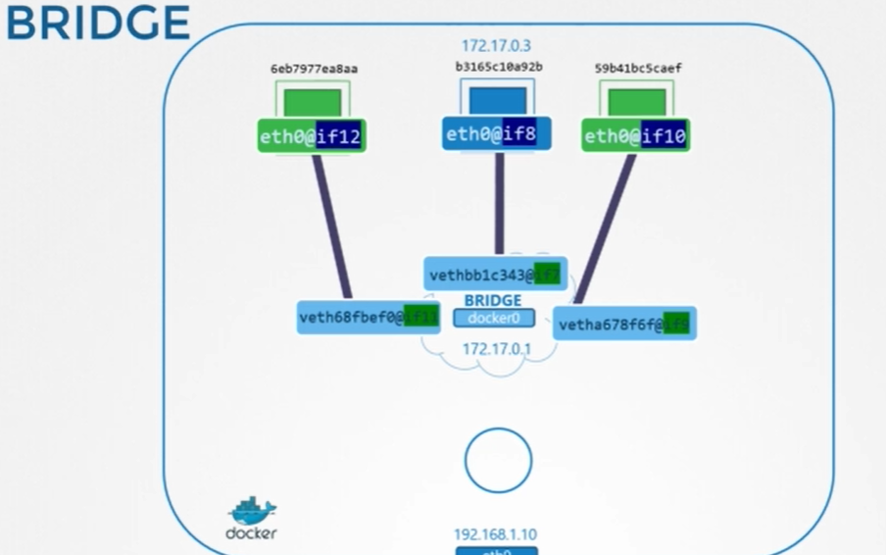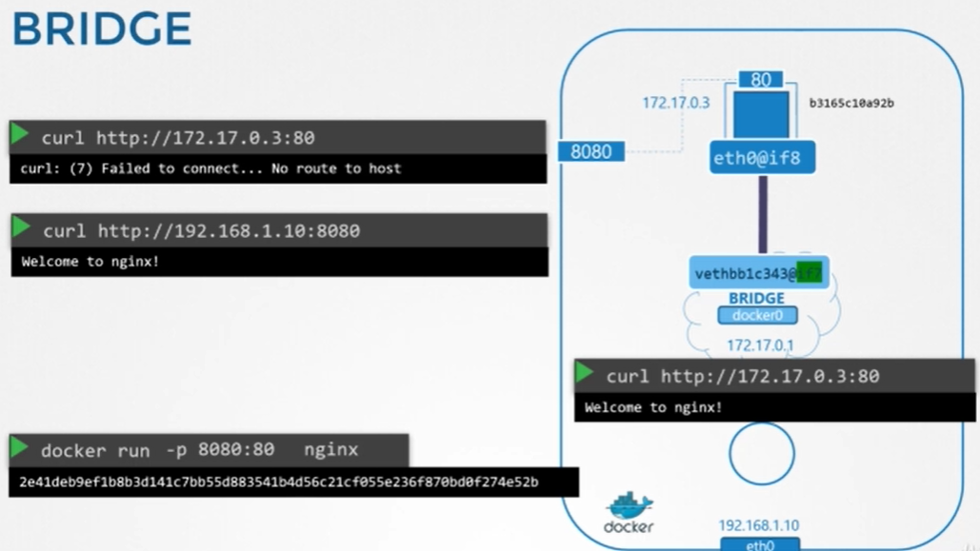

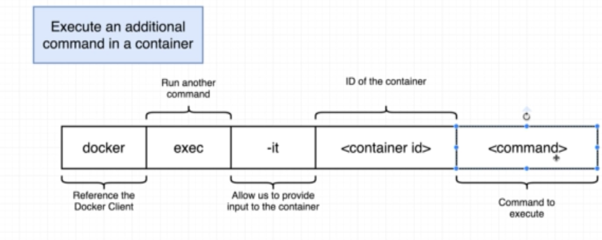

<https://www.udemy.com/course/docker-and-kubernetes-the-complete-guide/learn/lecture/11436964#overview>

Below are field selectors

kubectl get pods --field-selector status.phase=Running

kubectl get ingress --field-selector foo.bar=baz

kubectl get services --all-namespaces --field-selector metadata.namespace!=default

kubectl get pods --field-selector=status.phase!=Running,spec.restartPolicy=Always

kubectl get statefulsets,services --all-namespaces --field-selector metadata.namespace!=default

kubectl describe quota

Helm Chart: <https://www.bmc.com/blogs/kubernetes-helm-charts/>

There are three types of different services 1. NodePort 2. ClusterIP 3. LoadBalancer

NodePort is common/basic service type using which we could expose our application to the external world. In the below case , suppose we have niginx application which is running at port 80 (TargetPort) and mapping to 80 (Port) under Service objecet and then mapping to 3008 (NodePort) on Machine level ports and available port range is 30000 to 37000. Below we could see a single POD that run nigin app.

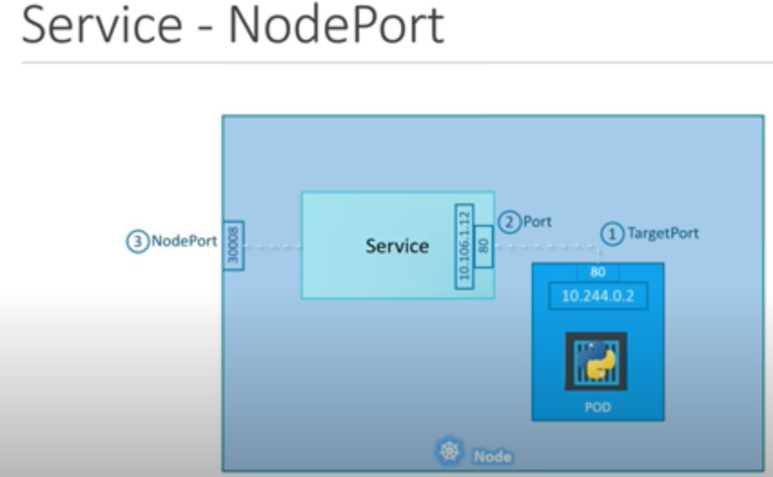

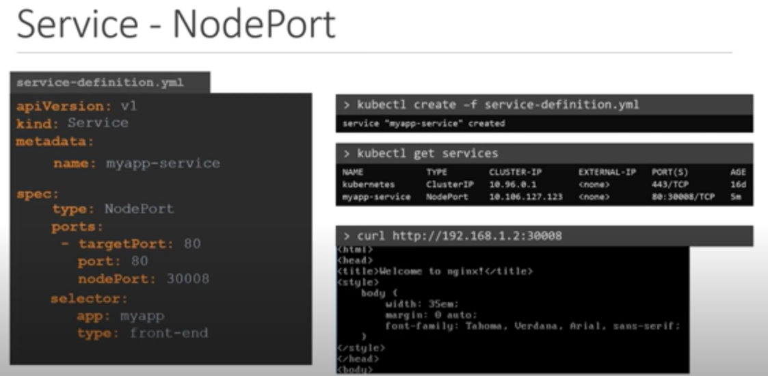

Below is the case where we have multiple PODS running/serving the same app assume that nginx running port 80 (TargetPort). Service Object itselft acts as loabalancer and distirbutes load across all the three PODs. This acts itself a inbuild Load Balancer and uses something called Algorithm: Random SessionAffinity: Yes. Note: Label should be the same across all the PODs

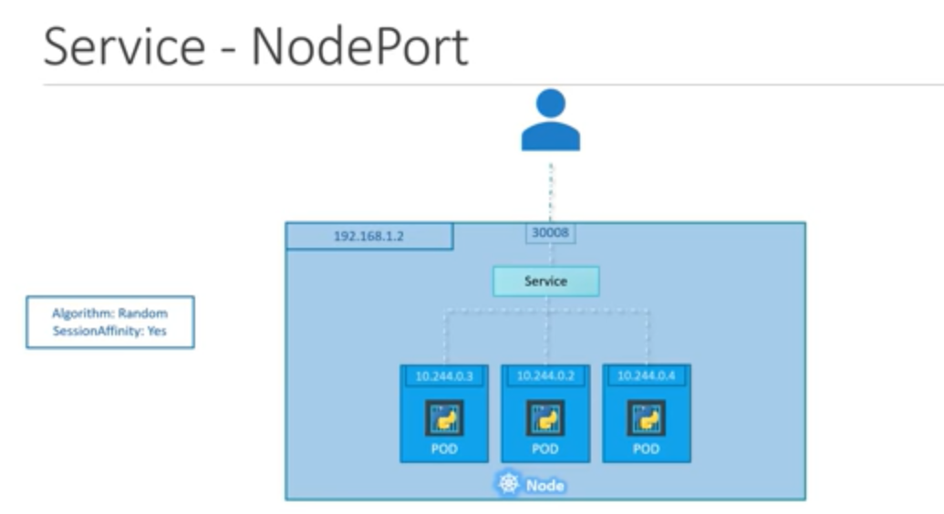

Below is the case where we deployed three same kind of nginx app running at TargetPort(80) in three different machine. In this case Service object acts LB and fulfill the incoming requests. We can ping our request using any of the cluster IP like mentioned below.

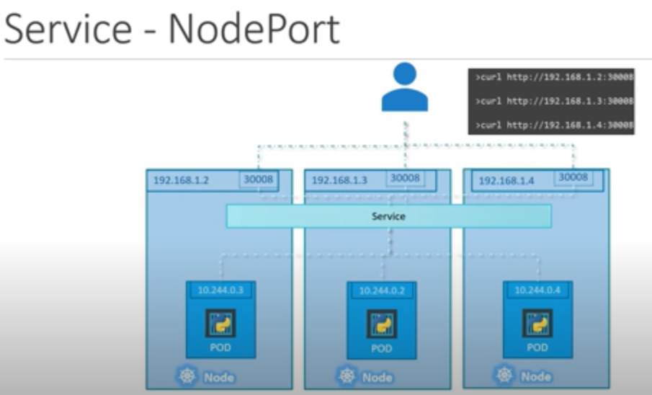

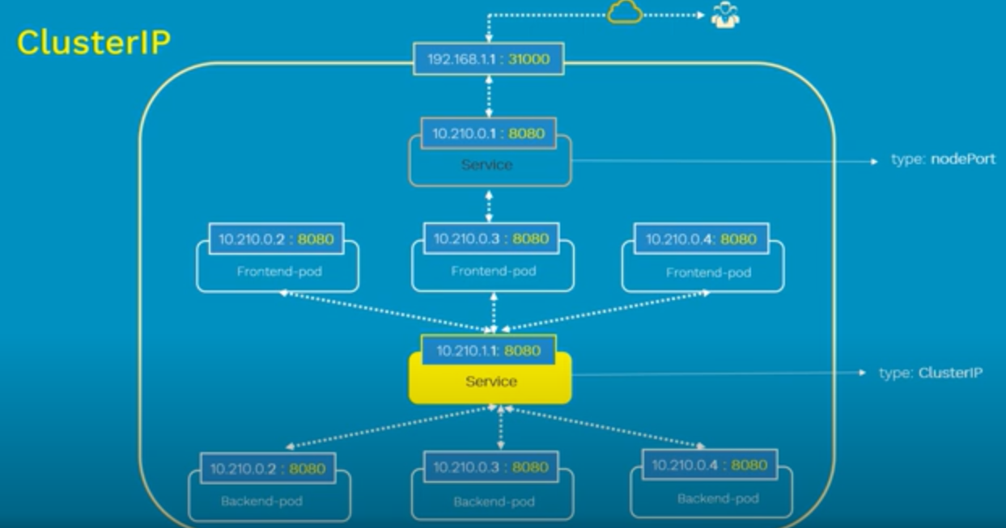

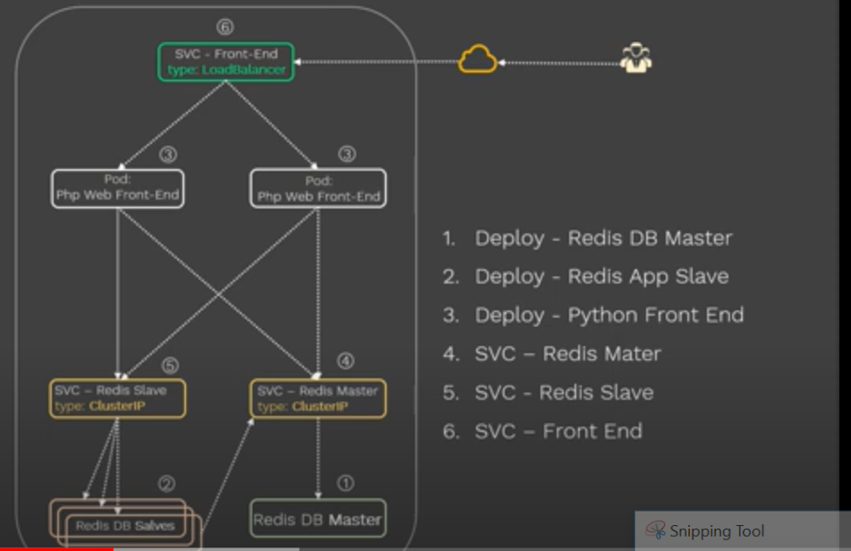

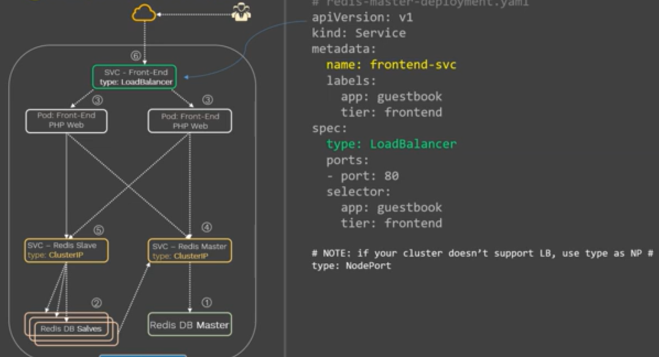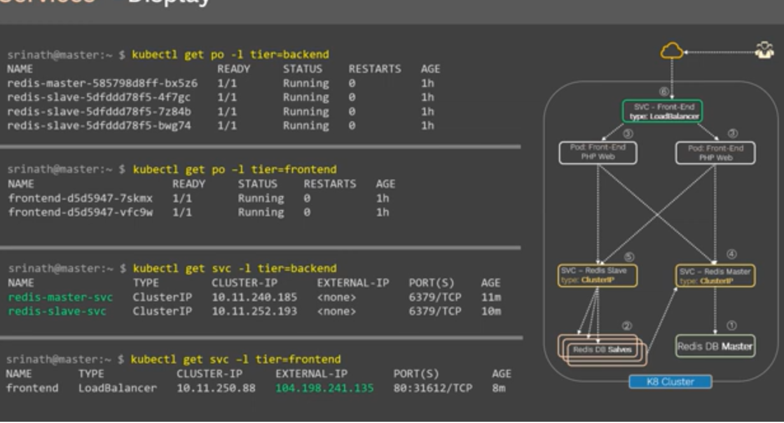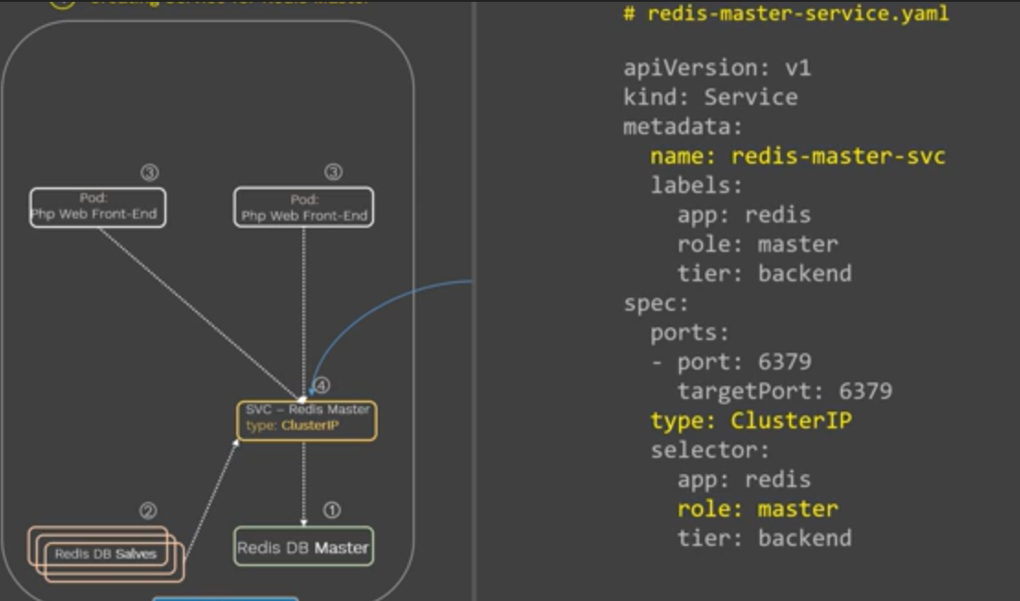

Kubectl get ep -n gamma (to get endpoints)

Kubectl get

Systemctl daemon-reload

kubectl cluster-info

journalctl -u kubelet

to know the version of etcd: kubectl exec -it etcd-master -- /bin/sh -c 'ETCDCTL_API=3 etcdctl version'

<https://rancher.com/blog/2019/2019-01-29-what-is-etcd/>

ETCDCTL_API=3 etcdctl version

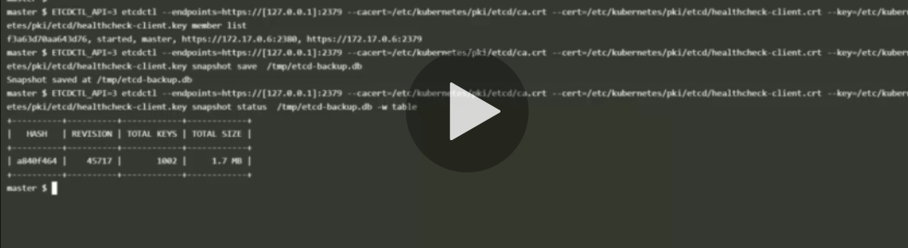

To genearate the dry run file

Kubectl run –generator=run-pod/v1 name –image=image:tag –dry-run -o yaml >> file.yaml

To be abel to systemtim for pod: <https://kubernetes.io/docs/tasks/configure-pod-container/security-context/>

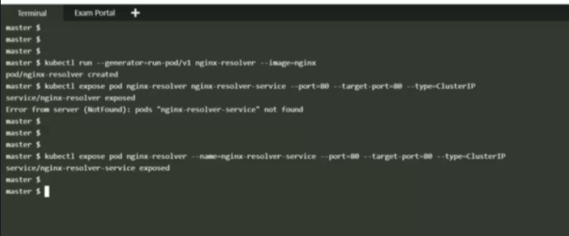



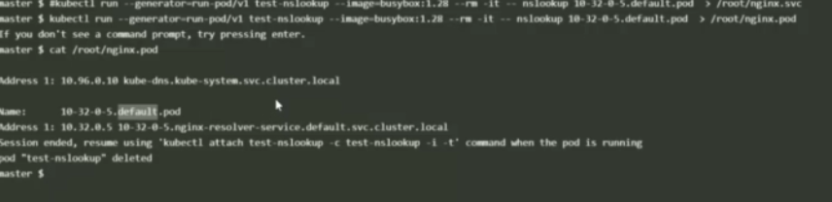

Container Network Interface (CNI) : kublet runs on 10250

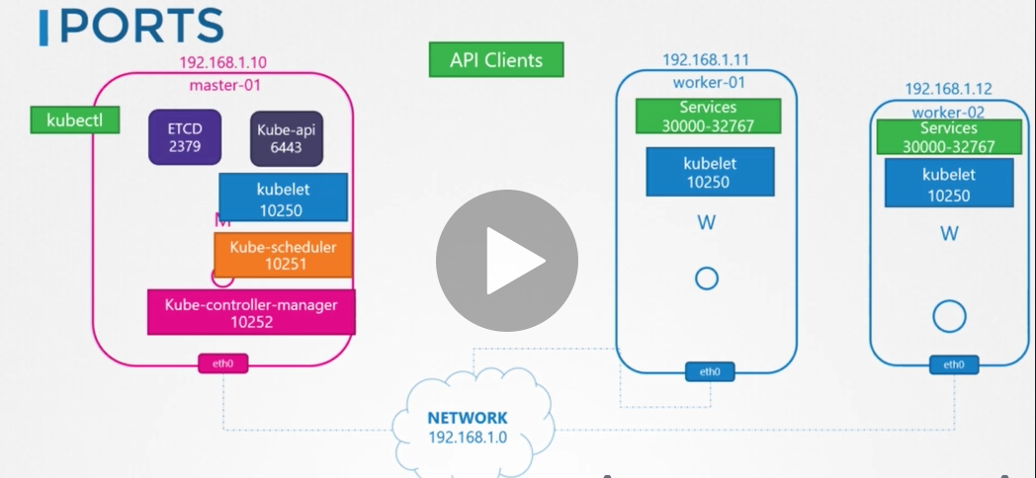

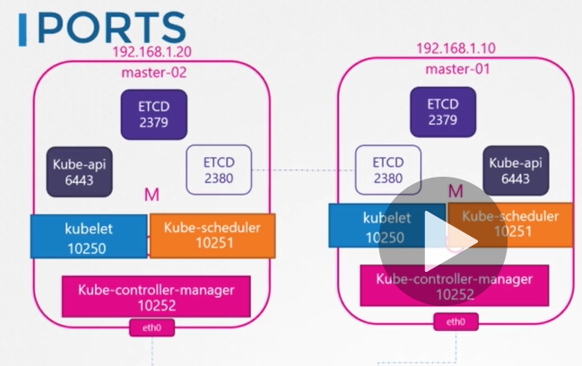

Using port 2380 ports both etcd in the cluster can communicate

Pod networking:

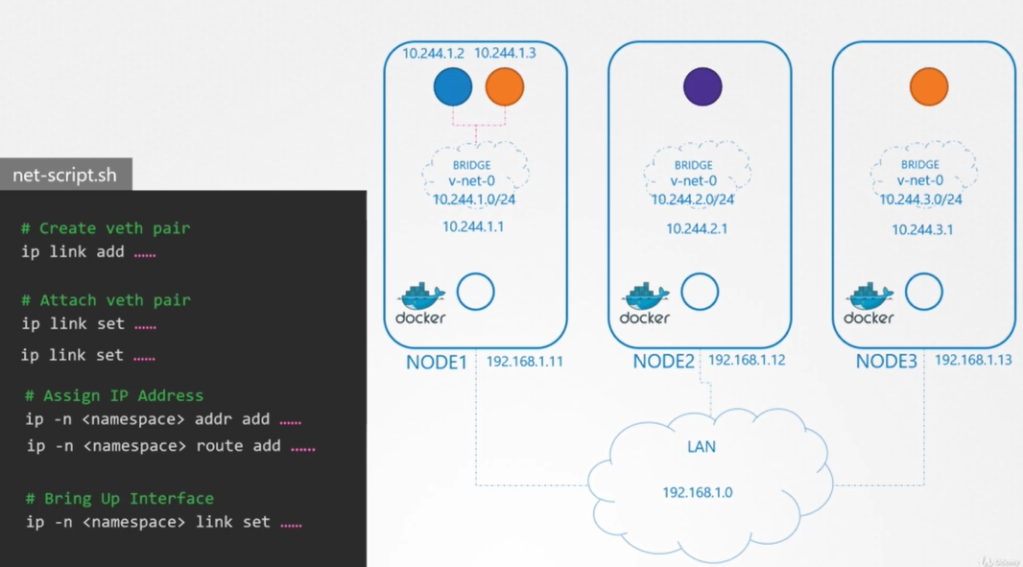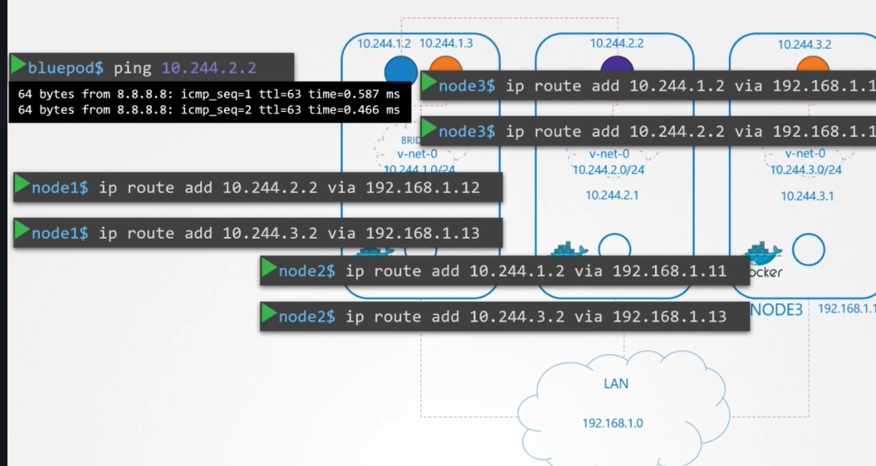

In order to establish communication among all the containers, we will have to run net-script.sh and adding to the routing tables. Instead simply we can use container network interface (CNI) to establish the network communication.

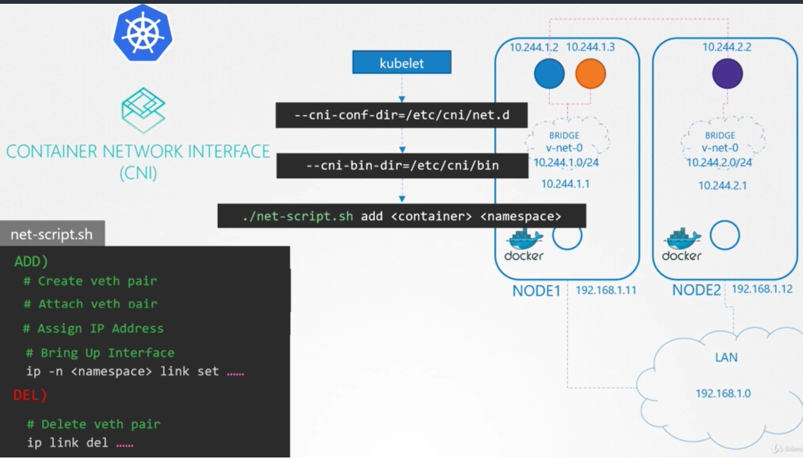

CNI plugin information mentiond in kubelet services file that is reponsibel for creating the contianers.

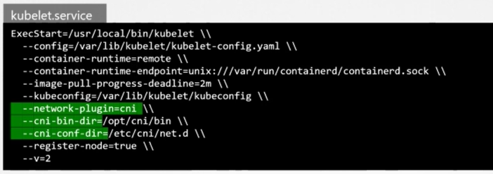

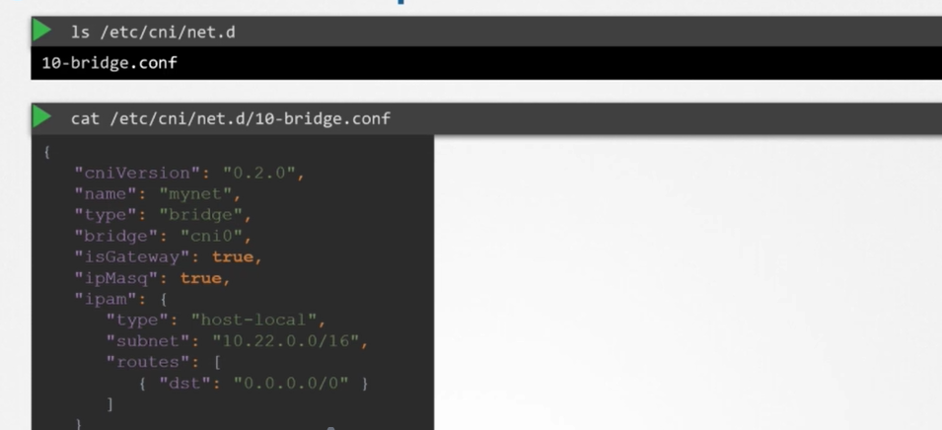

CNI shd be deployed on the nodes in the cluster so that it is can send the packets to the other weave/cni peers in the cluster.

Service netoworking;

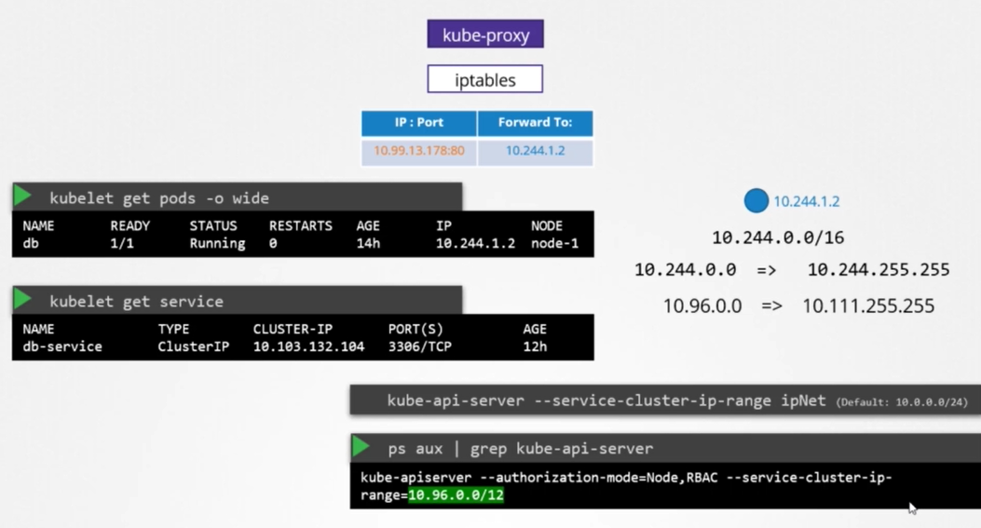

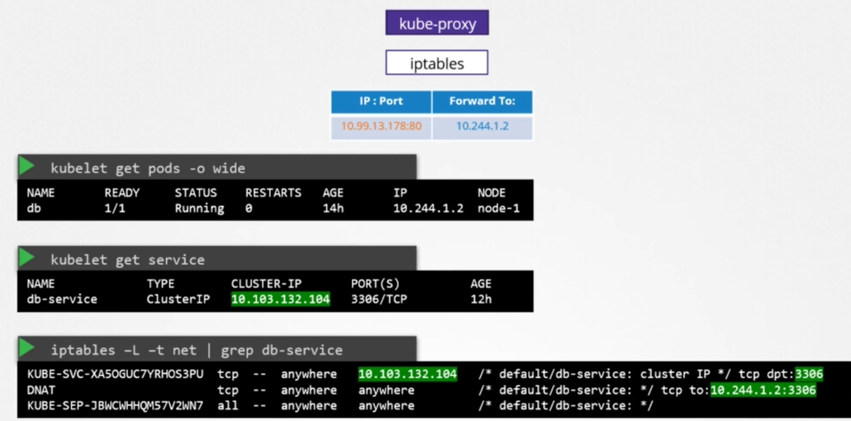

In the abouve service-cluster-ip range is the one which is configure in kube-api server and pods will container use the network range.

Ingress:

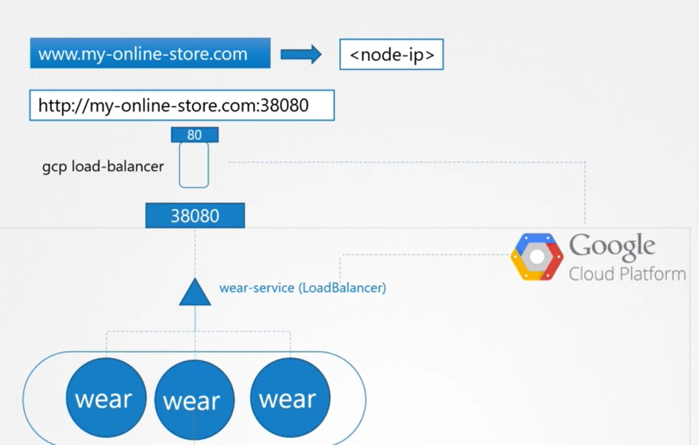

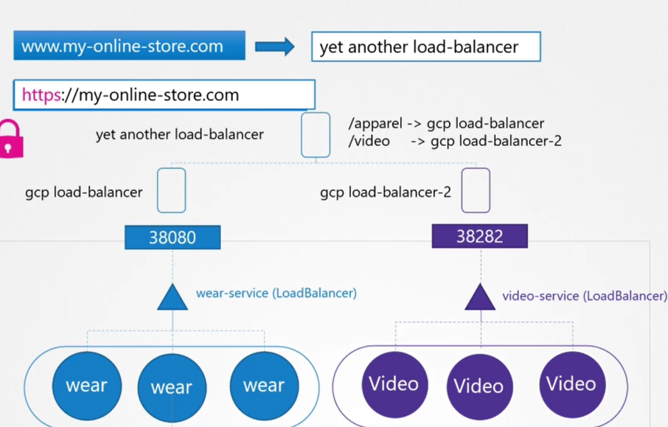

Ingress is a layer 7 load balancer build in Kubernetes. It is like nginx, HA Proxy,etc.

Ingress controller is not a default one, we shd deploy. We shd deploy, nginx. GC lB.

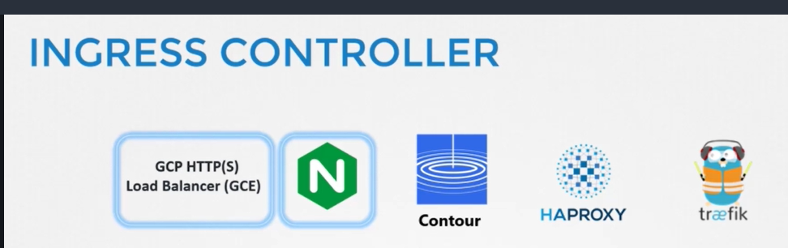

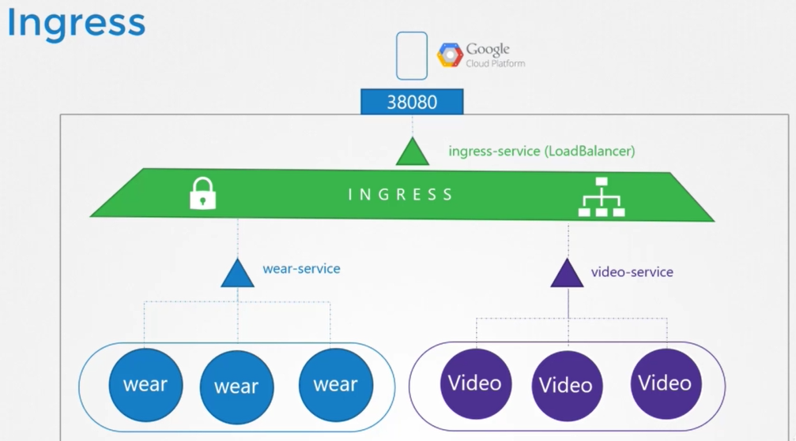



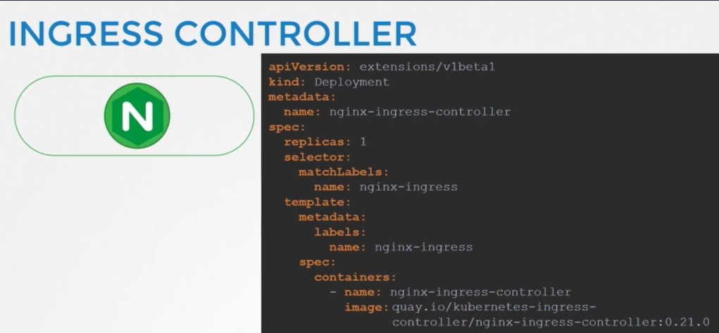

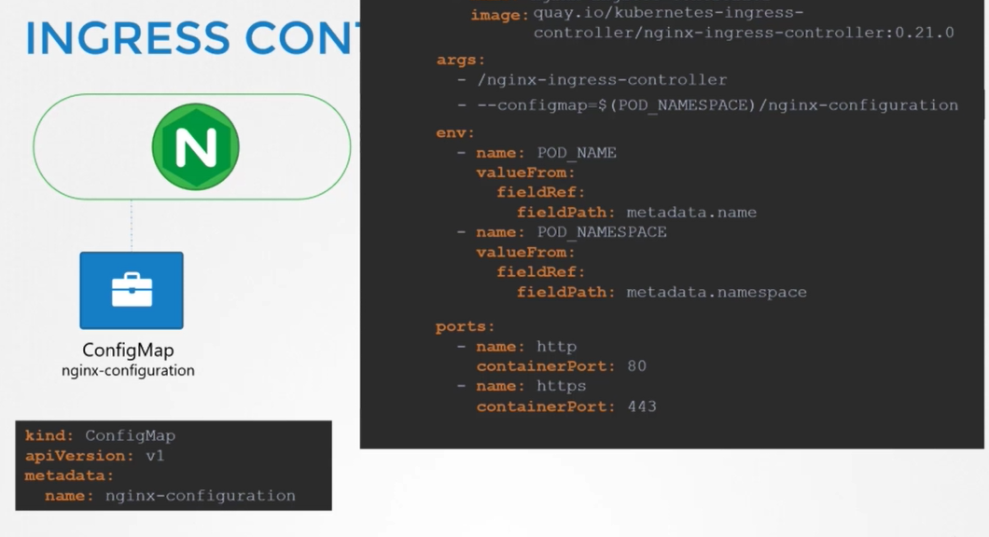

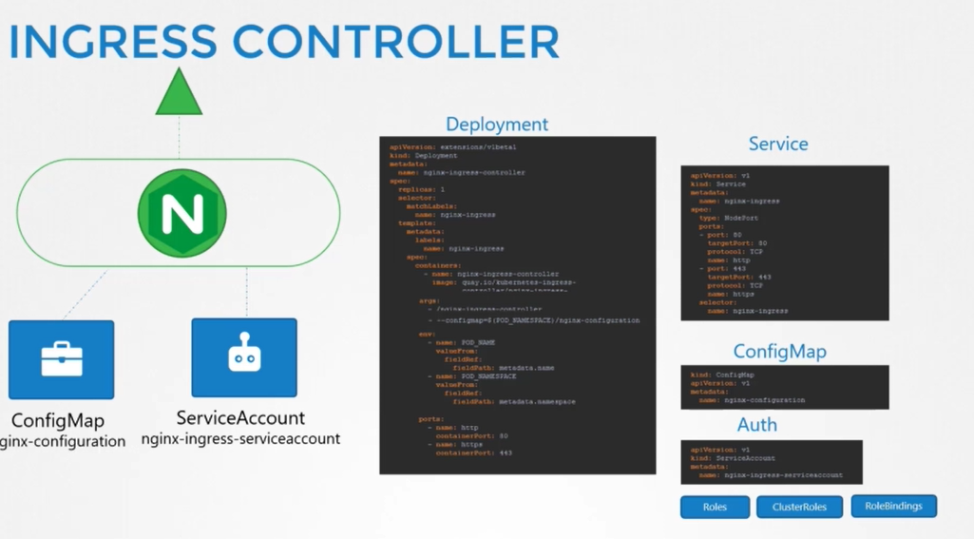

Creating ingress service

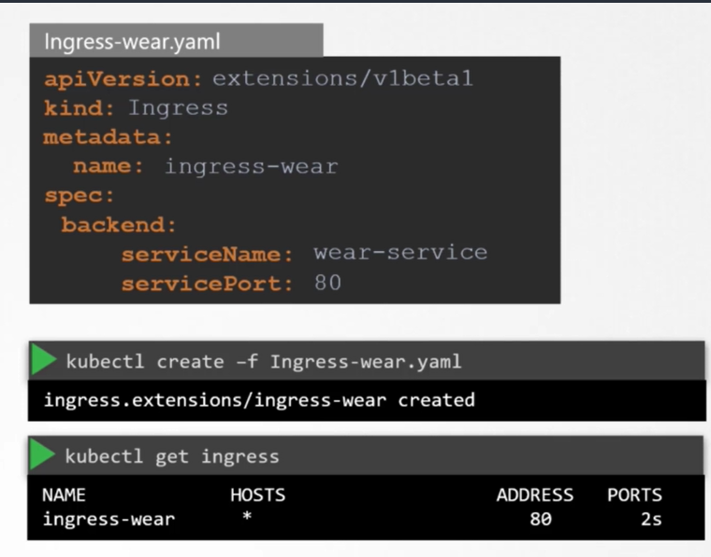

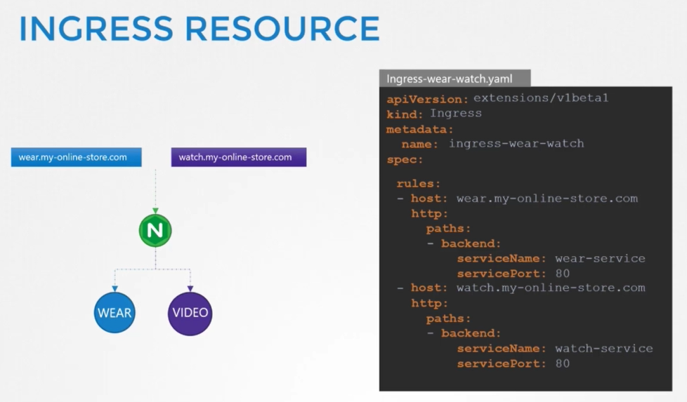

Ingress - Annotations and rewrite-target

Different ingress controllers have different options that can be used to customise the way it works. NGINX Ingress controller has many options that can be seen [here](https://kubernetes.github.io/ingress-nginx/examples/). I would like to explain one such option that we will use in our labs. The [Rewrite](https://kubernetes.github.io/ingress-nginx/examples/rewrite/) target option.

Our watch app displays the video streaming webpage at http://<watch-service>:<port>/

Our wear app displays the apparel webpage at http://<wear-service>:<port>/

We must configure Ingress to achieve the below. When user visits the URL on the left, his request should be forwarded internally to the URL on the right. Note that the /watch and /wear URL path are what we configure on the ingress controller so we can forwarded users to the appropriate application in the backend. The applications don't have this URL/Path configured on them:  
  
http://<ingress-service>:<ingress-port>/watch --> http://<watch-service>:<port>/

http://<ingress-service>:<ingress-port>/wear --> http://<wear-service>:<port>/

Without the rewrite-target option, this is what would happen:

http://<ingress-service>:<ingress-port>/watch --> http://<watch-service>:<port>/watch

http://<ingress-service>:<ingress-port>/wear --> http://<wear-service>:<port>/wear

Notice watch and wear at the end of the target URLs. The target applications are not configured with /watch or /wear paths. They are different applications built specifically for their purpose, so they don't expect /watch or /wear in the URLs. And as such the requests would fail and throw a 404 not found error.

To fix that we want to "ReWrite" the URL when the request is passed on to the watch or wear applications. We don't want to pass in the same path that user typed in. So we specify the rewrite-target option. This rewrites the URL by replacing whatever is under rules->http->paths->path which happens to be /pay in this case with the value in rewrite-target. This works just like a search and replace function.

For example: replace(path, rewrite-target)  
In our case: replace("/path","/")

1. apiVersion: extensions/v1beta1
2. kind: Ingress
3. metadata:
4. name: test-ingress
5. namespace: critical-space
6. annotations:
7. nginx.ingress.kubernetes.io/rewrite-target: /
8. spec:
9. rules:
10. - http:
11. paths:
12. - path: /pay
13. backend:
14. serviceName: pay-service
15. servicePort: 8282

In another example given [here](https://kubernetes.github.io/ingress-nginx/examples/rewrite/), this could also be:

replace("/something(/|$)(.*)", "/$2")

1. apiVersion: extensions/v1beta1
2. kind: Ingress
3. metadata:
4. annotations:
5. nginx.ingress.kubernetes.io/rewrite-target: /$2
6. name: rewrite
7. namespace: default
8. spec:
9. rules:
10. - host: rewrite.bar.com
11. http:
12. paths:
13. - backend:
14. serviceName: http-svc
15. servicePort: 80
16. path: /something(/|$)(.*)

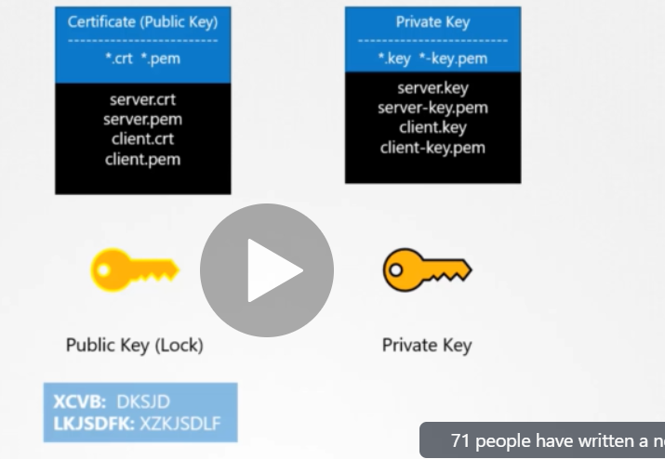

Server sends the public key(server.crt or server.pem) to CA authority. Here CA uses a private key to sign a csr cert. Then CA returns signed csr certificate to the server.

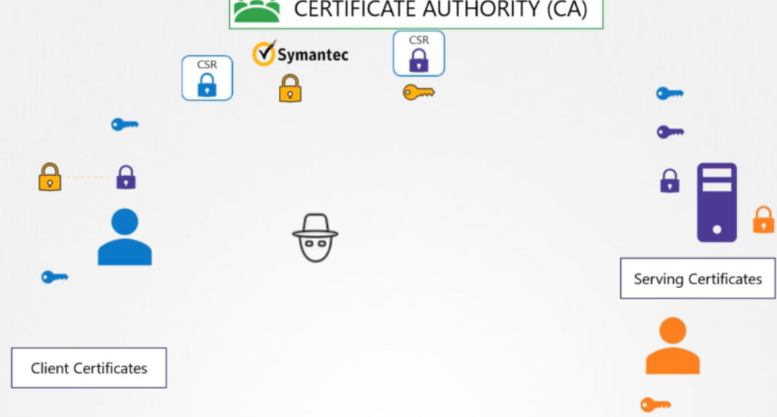

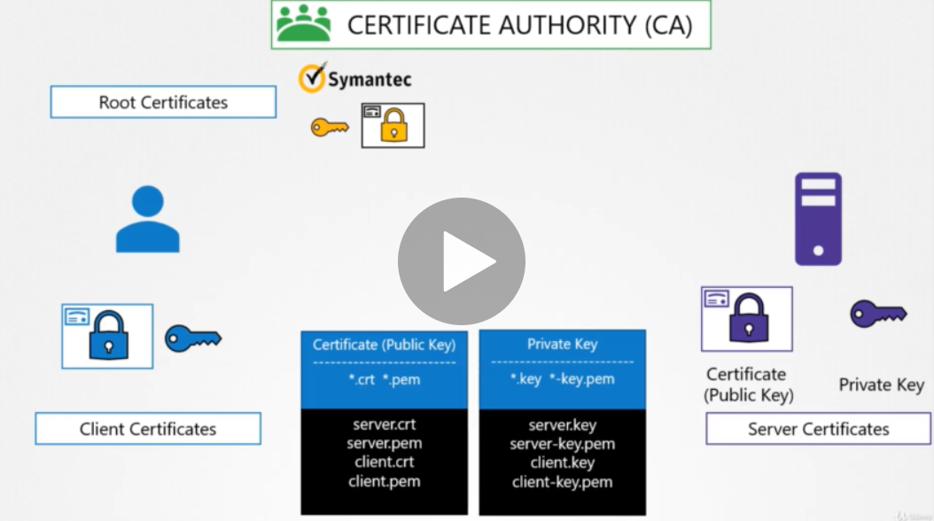

Generally public keys are always ends with crt or pem. Whereas private is itself has key in its name or as extension

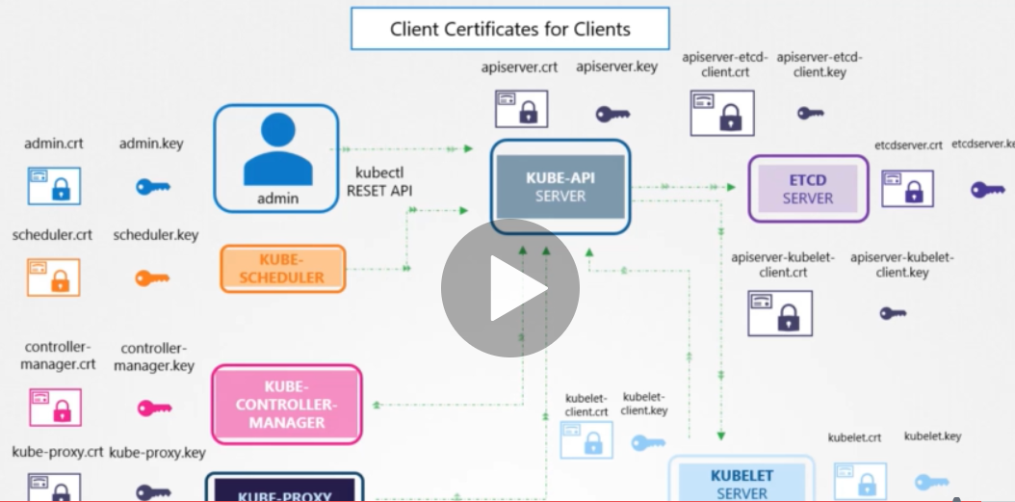

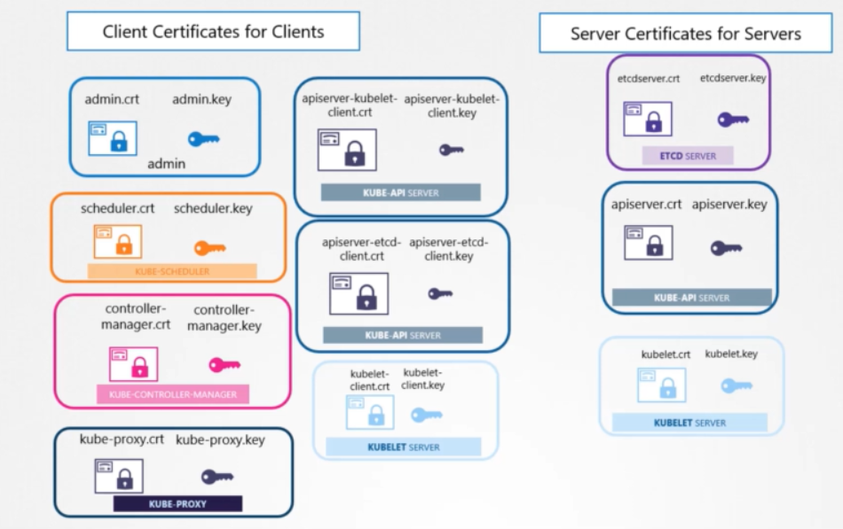

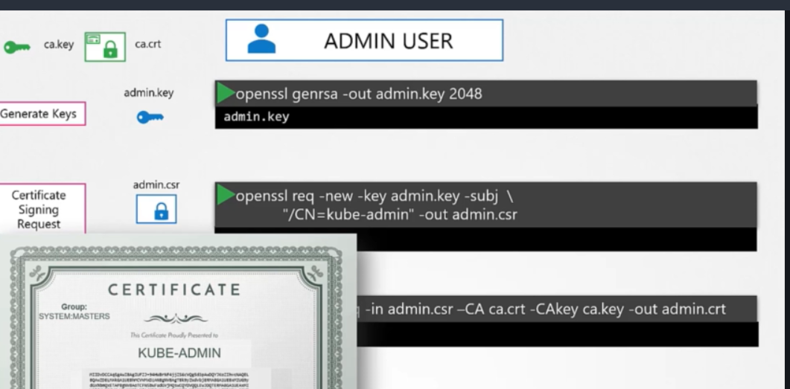

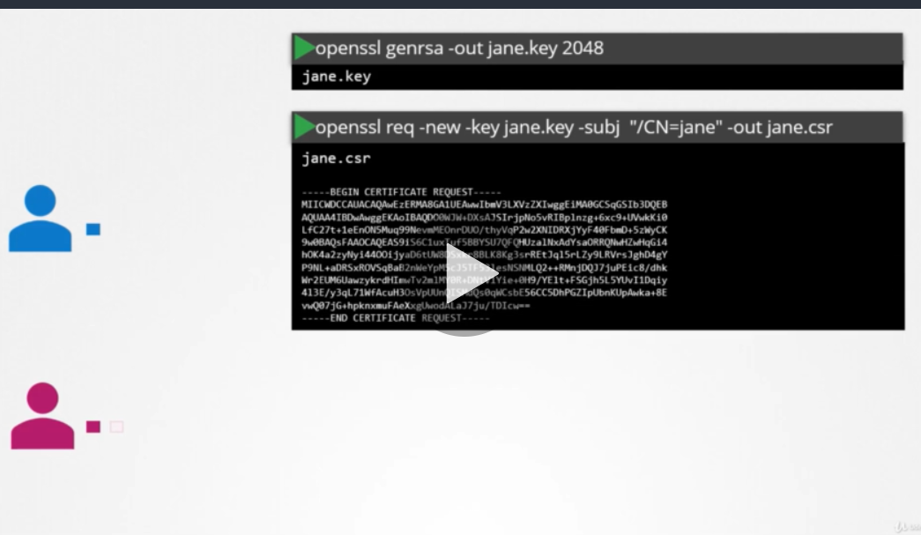

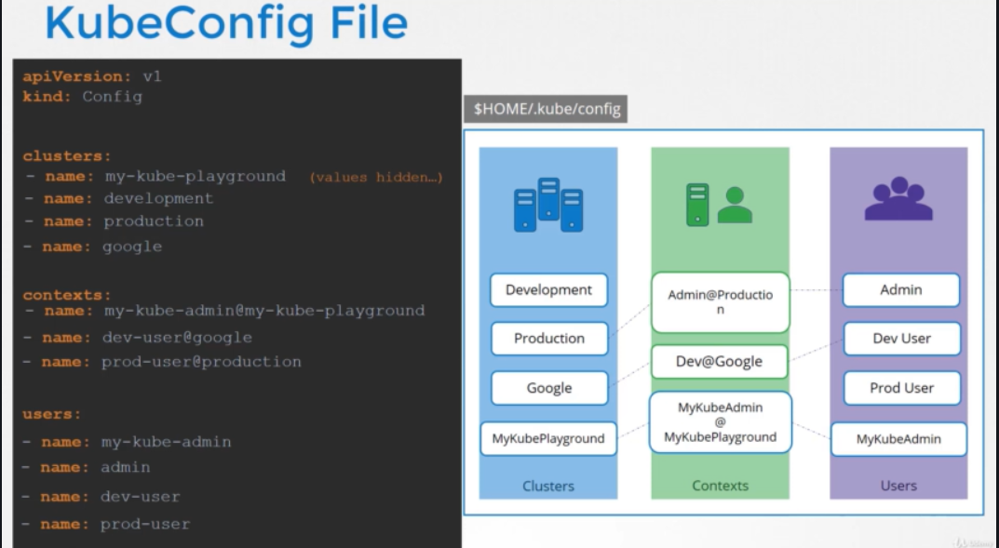

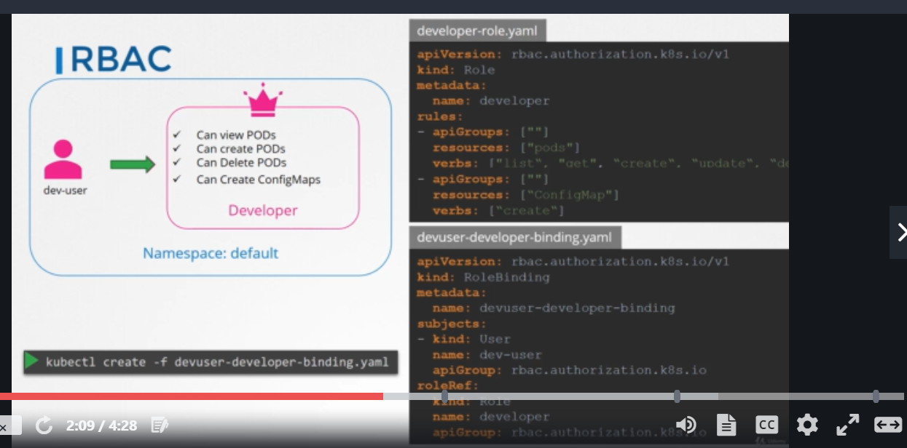

ROLE is set of instrucntion and permissions, rolebinding is a option where we you add the user to the roles

